**Data Analysis and Visualization Using Python**

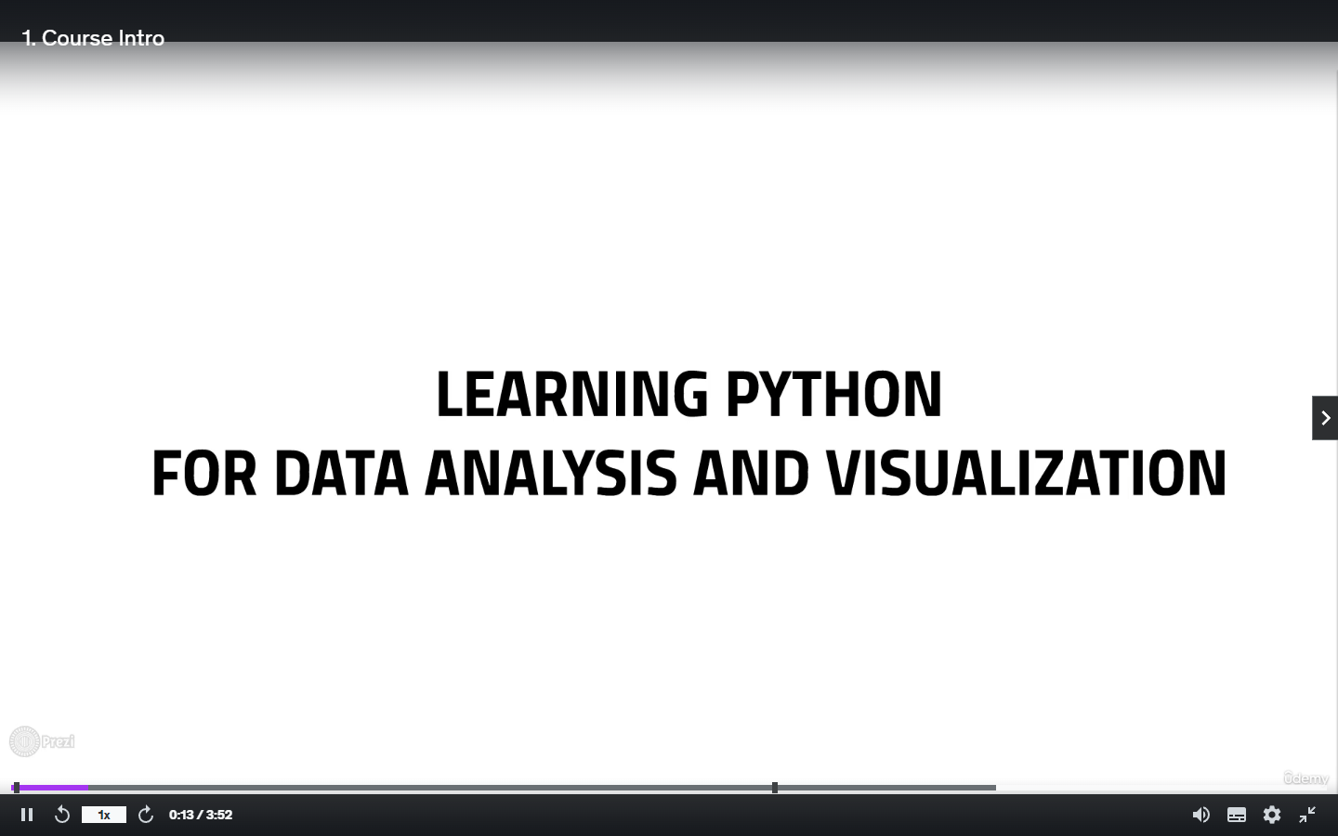

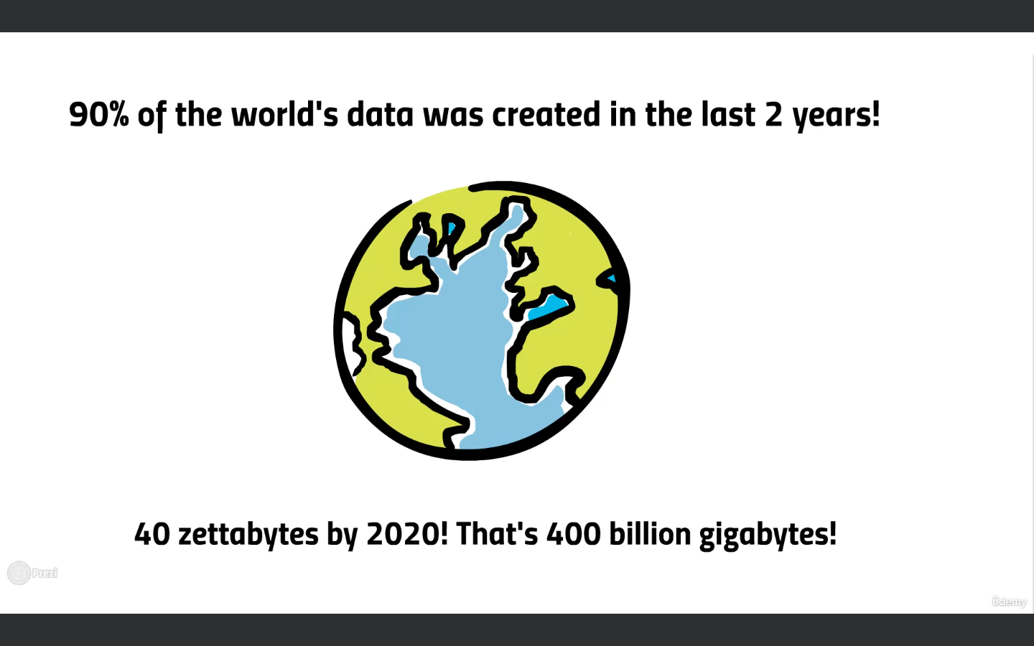



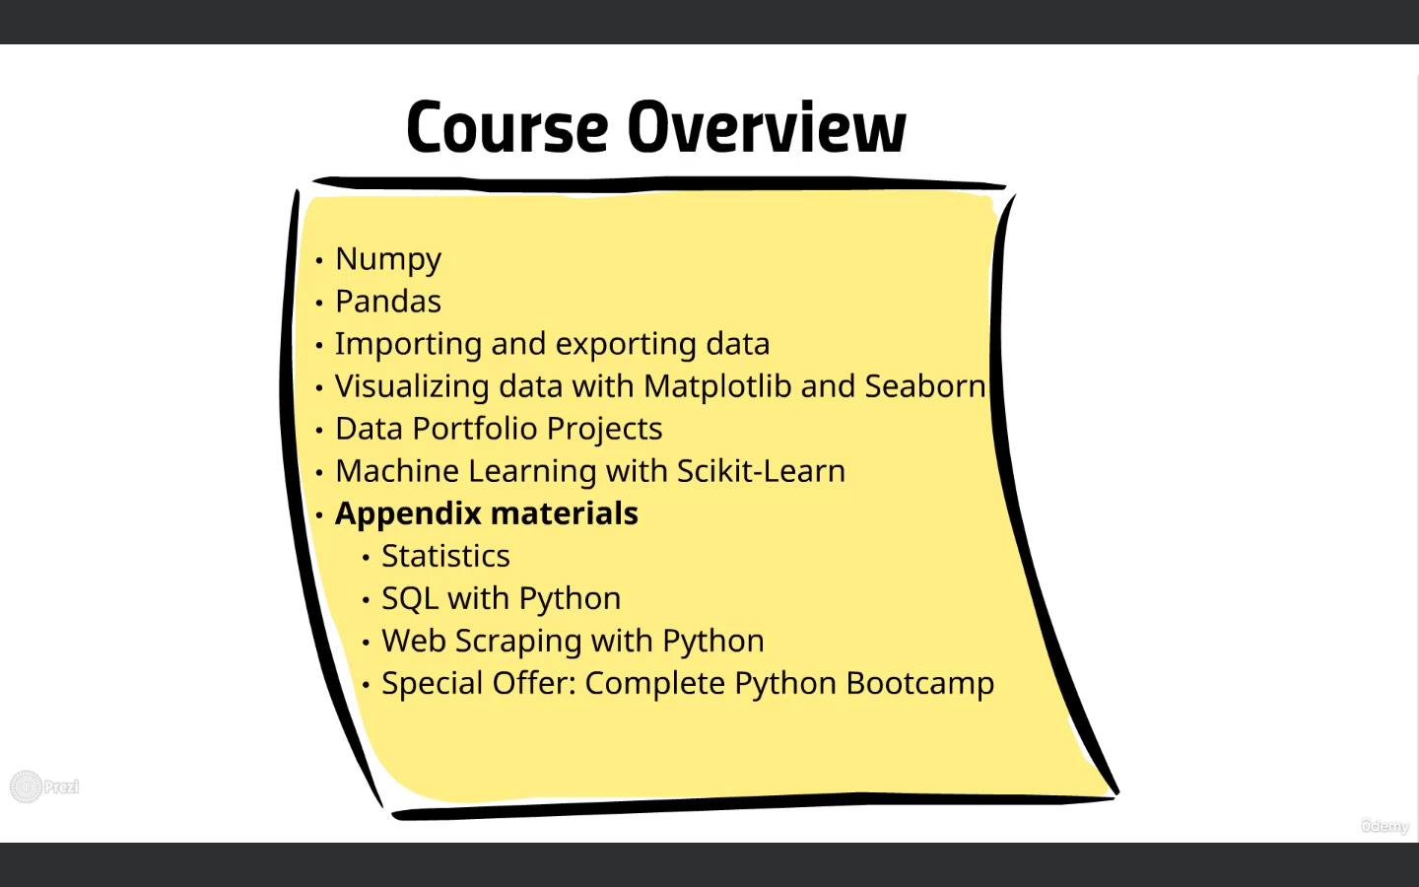

What is a Numpy?

Numpy is a fundamental package for Scientific Computing

NumPy is a library for the Python programming language, adding support for large, multi-dimensional arrays and matrices, along with a large collection of high-level mathematical functions to operate on these arrays. [Wikipedia](https://en.wikipedia.org/wiki/NumPy)

[**Programming languages**](https://www.google.com/search?sca_esv=557804163&rlz=1C1CHBF_enIN1049IN1049&q=numpy+programming+languages&stick=H4sIAAAAAAAAAOPgE-LUz9U3MDIsyEnS0skot9JPzs_JSU0uyczP0y_OTyspTyxKtSooyk8vSszNzcxLV8hJzEsvTUxPXcQqnVeaW1CpgE2yGACdGfk1WQAAAA&sa=X&ved=2ahUKEwjJgbG2keSAAxXXT2wGHVi3CdgQ6BMoAHoECEYQAg)**:**[Python](https://www.google.com/search?sca_esv=557804163&rlz=1C1CHBF_enIN1049IN1049&q=Python&si=ACFMAn86XkhxzOC35jo3k1ec_mUa4PwHgnEtN6tbGWMWaJ9RAvbMj0B5mT7rHlPnpBkMPQbMic1gLAvVxfVZg8wNTewIrF9gHZkinGGooKsObKThOblzvP6vyv5kexyWRkgI2Ygu9fk7oyKPQ9Q4GvYx7Q-O7HRA0mEcMCk4vKItDE_lTp2g19y3GwuWzTtQ-ldeLIomQhCWKOgEDBcZGBOAtZVmeLKj6H8KtAipnsUEpsd77jartShcMDOadCt7vLv_VBB7QyYozyBPdm4A5aK9mEo6D8k8qQ%3D%3D&sa=X&ved=2ahUKEwjJgbG2keSAAxXXT2wGHVi3CdgQmxMoAXoECEYQAw), [C](https://www.google.com/search?sca_esv=557804163&rlz=1C1CHBF_enIN1049IN1049&q=C&si=ACFMAn86XkhxzOC35jo3k1ec_mUa4PwHgnEtN6tbGWMWaJ9RAluVpatfZMwa2syj6Op4XCeGYkGnBx7EBvHLXA7AECYi7Xj6ys-Kgza7wDMC4qUPaZo0wZPEHySG7kstG3jPtHdbFAMqpUrgyJMFlzuhuh5JhsB6VLTljLULGnZ08O9q_scyG1tVSFPJfTNxkjbYlB1S70yoxLNkXiPbTUJan3wbbmGw_IgC3QHZBJVpRAi27lUbA4gWdFeXdYOw4GHBcHReliekzZe6Y9cBlqzU18cvuKZQBg%3D%3D&sa=X&ved=2ahUKEwjJgbG2keSAAxXXT2wGHVi3CdgQmxMoAnoECEYQBA)

[**Developer**](https://www.google.com/search?sca_esv=557804163&rlz=1C1CHBF_enIN1049IN1049&q=numpy+developer&stick=H4sIAAAAAAAAAOPgE-LUz9U3MDIsyEnSks9OttJPzs8tKC1JLdIvzk8rKU8sSrVKSS1LzckvSC1axMqfV5pbUKkAFwEAkEUdEUAAAAA&sa=X&ved=2ahUKEwjJgbG2keSAAxXXT2wGHVi3CdgQ6BMoAHoECEIQAg)**:**[Travis Oliphant](https://www.google.com/search?sca_esv=557804163&rlz=1C1CHBF_enIN1049IN1049&q=Travis+Oliphant&si=ACFMAn9guiESjt3hsdqUPIy1y2qa0157EysY45UH-07krUGxzkalit7baWNJyx0WtZAfpWnkuerxrPIzZ_zERCv65UJ2HqgXjsf1L49J6PddWREPoDmD80PqgV60CfcplBinLtLnlyBd9lWjuxTjSN0BfmFqPg3G-IFIRF7HrCDAgeT0PIOuioM2bxiCusvUPin8hpVl-s7n9kDYzRvs637_fzeSYZazGg%3D%3D&sa=X&ved=2ahUKEwjJgbG2keSAAxXXT2wGHVi3CdgQmxMoAXoECEIQAw)

[**Initial release**](https://www.google.com/search?sca_esv=557804163&rlz=1C1CHBF_enIN1049IN1049&q=numpy+initial+release&sa=X&ved=2ahUKEwjJgbG2keSAAxXXT2wGHVi3CdgQ6BMoAHoECEkQAg)**:**As Numeric, 1995; as NumPy, 2006

[**License**](https://www.google.com/search?sca_esv=557804163&rlz=1C1CHBF_enIN1049IN1049&q=numpy+license&sa=X&ved=2ahUKEwjJgbG2keSAAxXXT2wGHVi3CdgQ6BMoAHoECEQQAg)**:**BSD

[**Repository**](https://www.google.com/search?sca_esv=557804163&rlz=1C1CHBF_enIN1049IN1049&q=numpy+repository&sa=X&ved=2ahUKEwjJgbG2keSAAxXXT2wGHVi3CdgQ6BMoAHoECEMQAg)**:**[github.com](https://www.google.com/search?sca_esv=557804163&rlz=1C1CHBF_enIN1049IN1049&q=github.com&stick=H4sIAAAAAAAAAONgVuLSz9U3KLZMzqjIXsTKlZ5ZklGapJecnwsAj05Q7RsAAAA&sa=X&ved=2ahUKEwjJgbG2keSAAxXXT2wGHVi3CdgQmxMoAXoECEMQAw)/numpy/numpy

[**Stable release**](https://www.google.com/search?sca_esv=557804163&rlz=1C1CHBF_enIN1049IN1049&q=numpy+stable+release&sa=X&ved=2ahUKEwjJgbG2keSAAxXXT2wGHVi3CdgQ6BMoAHoECEcQAg)**:**1.25.1 / 8 July 2023; 36 days ago

What is a Pandas?

pandas is a software library written for the Python programming language for data manipulation and analysis. In particular, it offers data structures and operations for manipulating numerical tables and time series. It is free software released under the three-clause BSD license. [Wikipedia](https://en.wikipedia.org/wiki/Pandas_(software))

[**Initial release date**](https://www.google.com/search?sca_esv=557804163&rlz=1C1CHBF_enIN1049IN1049&q=pandas+initial+release+date&stick=H4sIAAAAAAAAAOPgE-LSz9U3KCrIKCgo1FLOKLfST87PyUlNLsnMz9Mvzk8rKU8sSrVKLChITSxSSEksSV3EKl2QmJeSWKyQmZdZkpmYo1CUmpOaWJwKlgUAne4MQFEAAAA&sa=X&ved=2ahUKEwjY5eCAkuSAAxX0zjgGHRKhBLgQ6BMoAHoECFEQAg)**:**11 January 2008

[**Programming languages**](https://www.google.com/search?sca_esv=557804163&rlz=1C1CHBF_enIN1049IN1049&q=pandas+programming+languages&stick=H4sIAAAAAAAAAOPgE-LSz9U3KCrIKCgo1NLJKLfST87PyUlNLsnMz9Mvzk8rKU8sSrUqKMpPL0rMzc3MS1fIScxLL01MT13EKlOQmJeSWKyATbYYAPDY8QZbAAAA&sa=X&ved=2ahUKEwjY5eCAkuSAAxX0zjgGHRKhBLgQ6BMoAHoECFAQAg)**:**[Python](https://www.google.com/search?sca_esv=557804163&rlz=1C1CHBF_enIN1049IN1049&q=Python&si=ACFMAn86XkhxzOC35jo3k1ec_mUa4PwHgnEtN6tbGWMWaJ9RAnReDZ8lGp_zHrHO2SsWIRIoe8nNjNsj_zhSwCxOAmNq8pdWEtiWZfBzspF2dL0vkGSscVz_TIWE13P4y1JWts1P7MhlEXoocSDoww9x3zx7IOF_YSuJj92pmbM1M2LE75Id4CdxVl23dYZl4Zf9DkPyFRu3D5nHPXznVEzLRKKwTh2Crltb71lNU1xDk2kWOUwmCJXHoRMpihh2_773PJdO2ZX8uzthSq98LccI-P8v_xWing%3D%3D&sa=X&ved=2ahUKEwjY5eCAkuSAAxX0zjgGHRKhBLgQmxMoAXoECFAQAw), [C](https://www.google.com/search?sca_esv=557804163&rlz=1C1CHBF_enIN1049IN1049&q=C&si=ACFMAn86XkhxzOC35jo3k1ec_mUa4PwHgnEtN6tbGWMWaJ9RApP_9B9vJbNoixUeJPNAGGqhU1jNxoB2CTSecqA2V1QKMUHpoXjAgD1BizOPX4a_W114S4jfXNN_MffucFE8T7EyI5VB-Ytbq6XvmCBq2T-iQ1eudUa-tv7FyyllXmljTcIihHiAHvK-lqScaiBQuxh1Hqj_SSlOUXUI1GTFEXlSRk2-TsuM-OJqCYK1i3t-EovaQbz6eWVGFTqyYvsvm5qbPe2WNkeQ5q6tuUC8zN3sr2kSCQ%3D%3D&sa=X&ved=2ahUKEwjY5eCAkuSAAxX0zjgGHRKhBLgQmxMoAnoECFAQBA), [Cython](https://www.google.com/search?sca_esv=557804163&rlz=1C1CHBF_enIN1049IN1049&q=Cython&si=ACFMAn8gKcw6L8cgu575hwcueyKgoe9ZYQ1m1yJZTLKy7VGJ2rSAd6NEzz9bLG9flZI4fMAyQASB7e9LxCr-k_Ia2PkPKVbRK37nSvq_J8jUBK2TxTSJQajKLFL2z0WVtR3CLSh1d4aR9LqRC-1J0kve53LG7B350ezCrJ4lihfLs48bz-vaptajmPoJZKsgfNOqHo4bXJtlOuPiDhqfLAUrjWISY-okUacxr04E2LPejDAp2SrMV7JbyiAhiVwdyj_dlC-HRA-_m0FImAeBOF2Ux26-W0qjxFlQ5HAssAjJ_gWz8ROV7rs%3D&sa=X&ved=2ahUKEwjY5eCAkuSAAxX0zjgGHRKhBLgQmxMoA3oECFAQBQ)

[**Developer**](https://www.google.com/search?sca_esv=557804163&rlz=1C1CHBF_enIN1049IN1049&q=pandas+developer&stick=H4sIAAAAAAAAAOPgE-LSz9U3KCrIKCgo1JLPTrbST87PLSgtSS3SL85PKylPLEq1SkktS83JL0gtWsQqUJCYl5JYrAAXAgChPJX9QgAAAA&sa=X&ved=2ahUKEwjY5eCAkuSAAxX0zjgGHRKhBLgQ6BMoAHoECE4QAg)**:**[Wes McKinney](https://www.google.com/search?sca_esv=557804163&rlz=1C1CHBF_enIN1049IN1049&q=Wes+McKinney&si=ACFMAn9guiESjt3hsdqUPIy1y2qa0157EysY45UH-07krUGxzuU0AA1DSIvL8yCXAdZHUqTrlFa5niBTzUjuIf4NDQEiuNfOH4WlvyiaHyHBGepqAAzLTFaXaEcDPEqZDELf1bR9AoudFv99VGXzw87ERM2TYDLWExVxz6sf8MaiqbFStS4u7uEh7jgZ4TAkfyVmhXMnWH-juV_Q0dGEQ4du1G15v7O1YA%3D%3D&sa=X&ved=2ahUKEwjY5eCAkuSAAxX0zjgGHRKhBLgQmxMoAXoECE4QAw)

[**License**](https://www.google.com/search?sca_esv=557804163&rlz=1C1CHBF_enIN1049IN1049&q=pandas+license&sa=X&ved=2ahUKEwjY5eCAkuSAAxX0zjgGHRKhBLgQ6BMoAHoECFIQAg)**:**[New BSD License](https://www.google.com/search?sca_esv=557804163&rlz=1C1CHBF_enIN1049IN1049&q=New+BSD+License&stick=H4sIAAAAAAAAAONgVuLSz9U3MCovKTLPWMTK75daruAU7KLgk5mcmlecCgATUBLrIAAAAA&sa=X&ved=2ahUKEwjY5eCAkuSAAxX0zjgGHRKhBLgQmxMoAXoECFIQAw)

[**Preview release**](https://www.google.com/search?sca_esv=557804163&rlz=1C1CHBF_enIN1049IN1049&q=pandas+preview+release&sa=X&ved=2ahUKEwjY5eCAkuSAAxX0zjgGHRKhBLgQ6BMoAHoECFcQAg)**:**2.0rc1 / 15 March 2023

Learn how to use pandas with python to create high-performance data structure, Learn how to use pandas to create data series, DataFrames, and quick and effective analysis on your Data.

Learn about Pandas to Build in Visualization tools

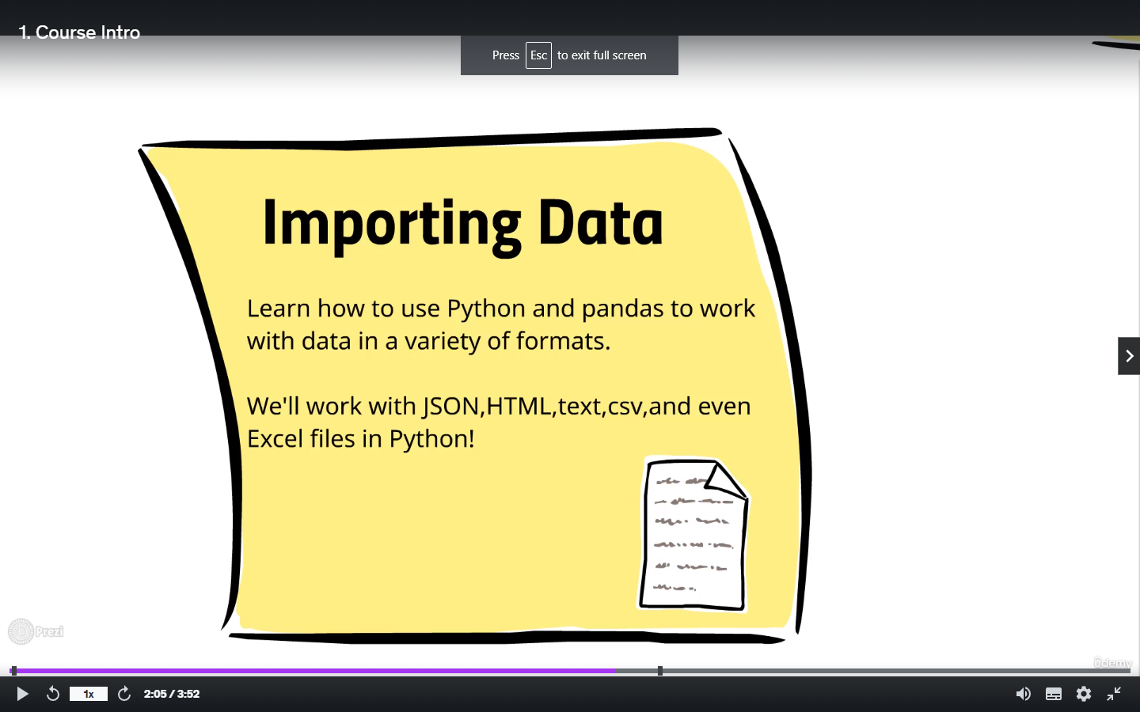

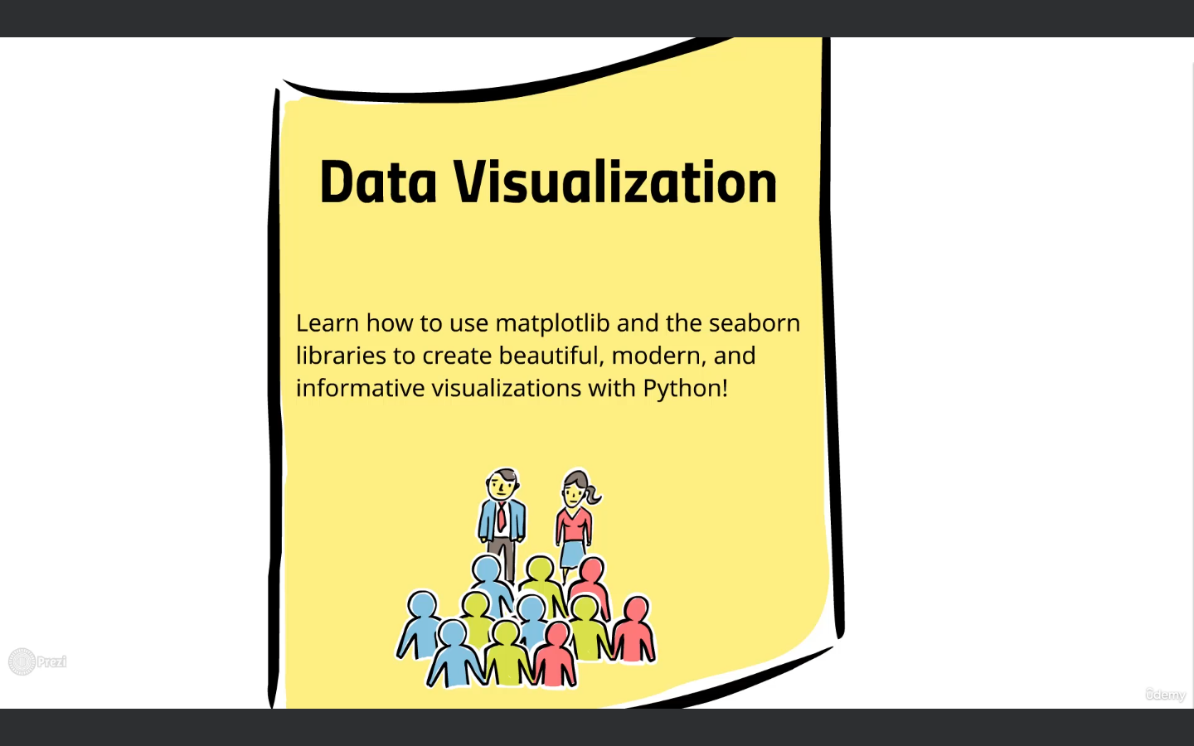

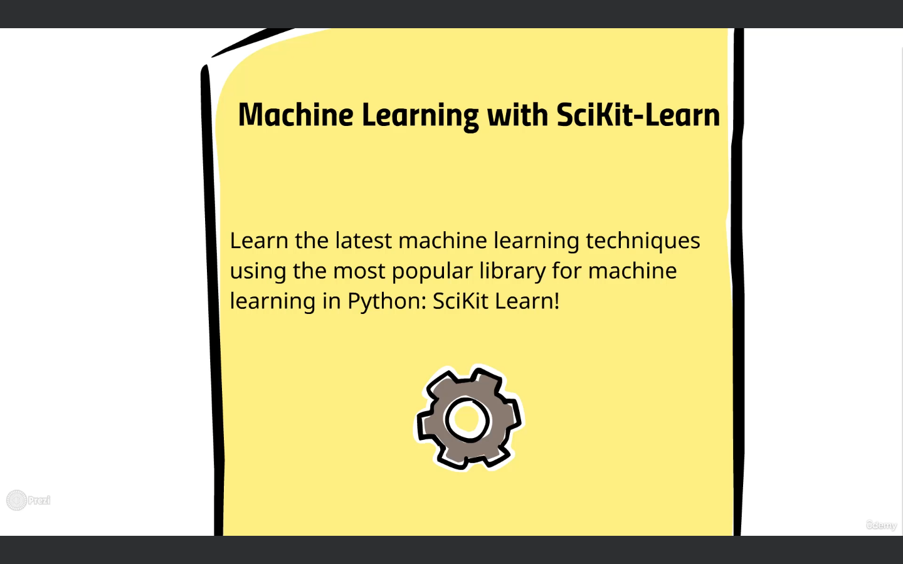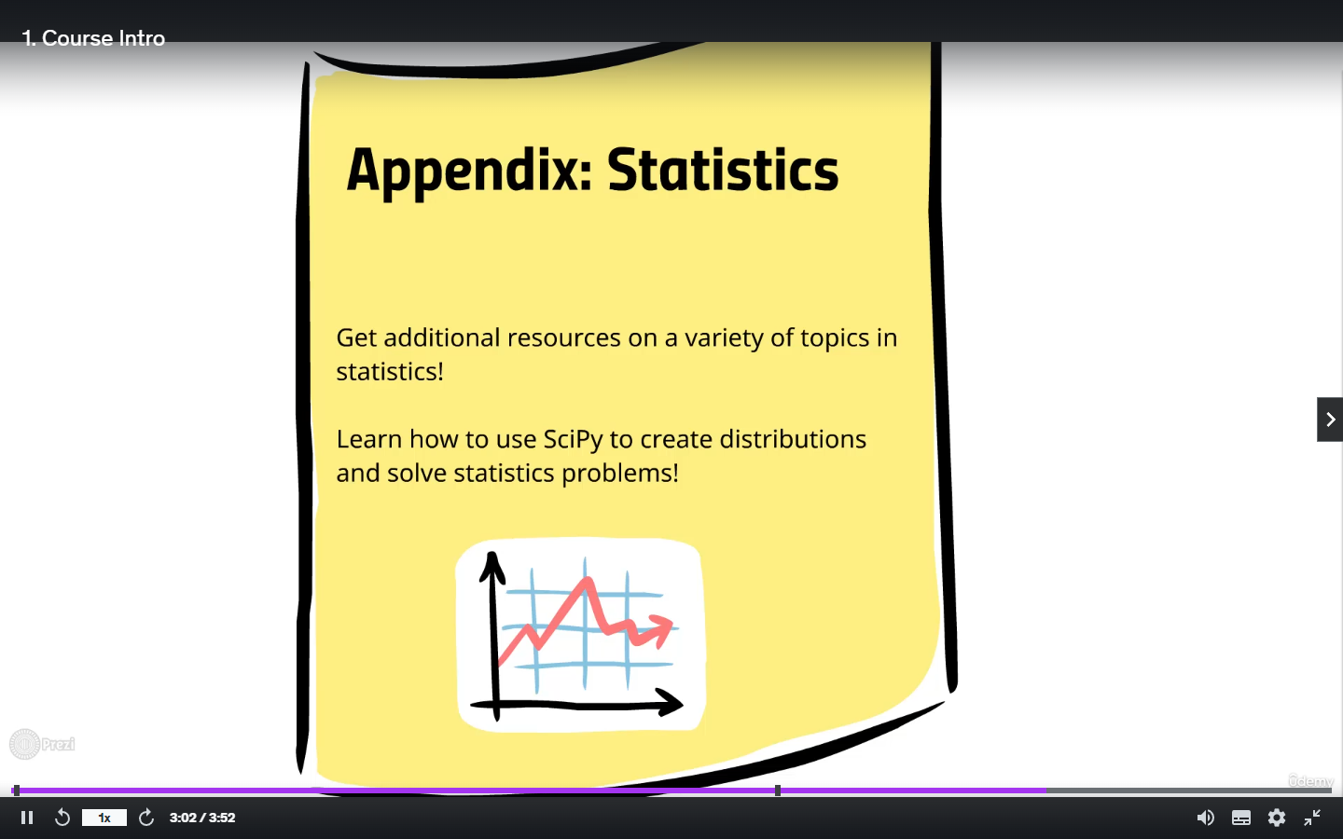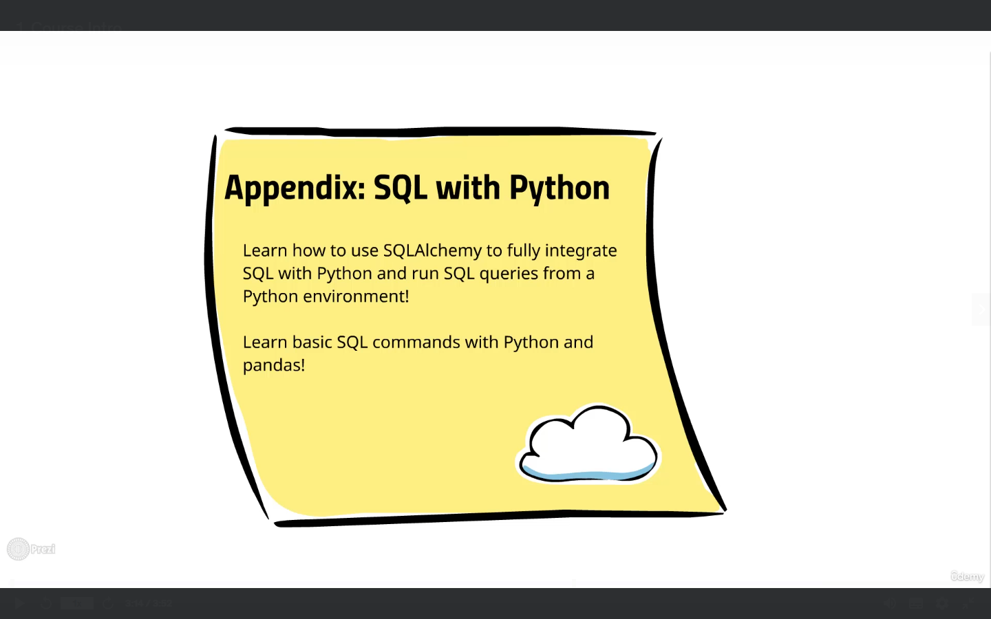

Array Processing

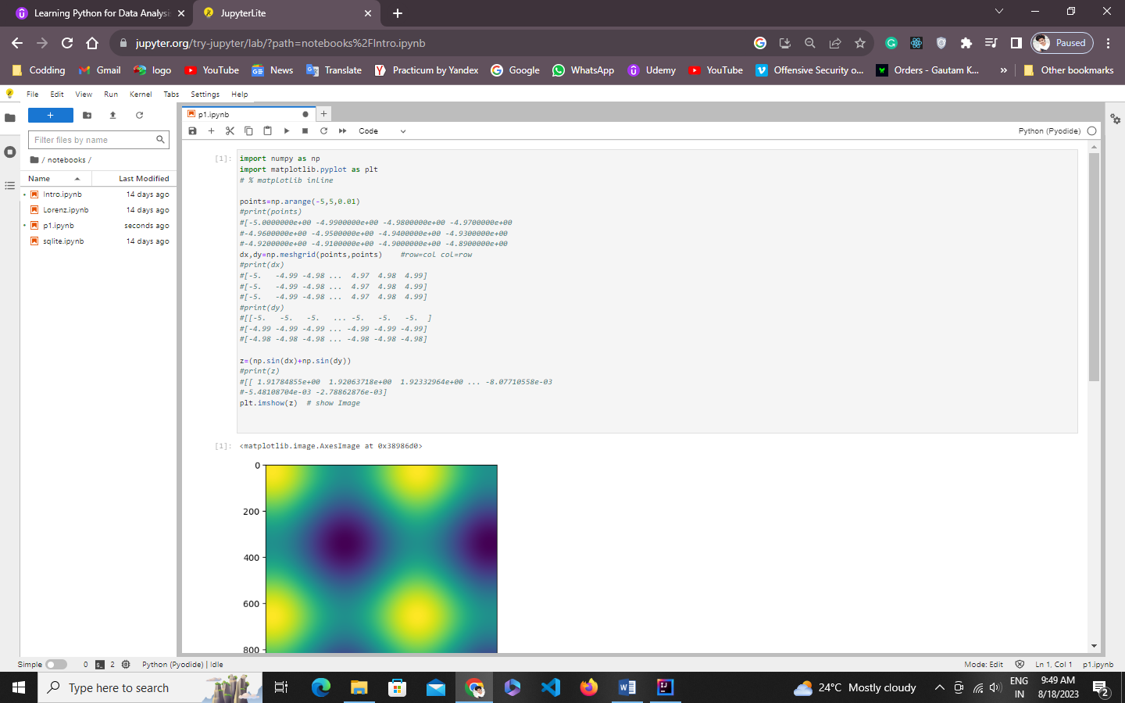

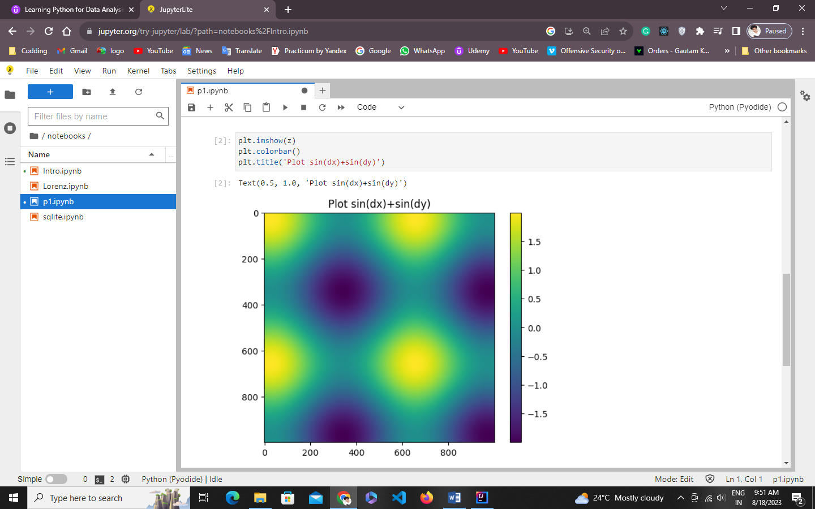

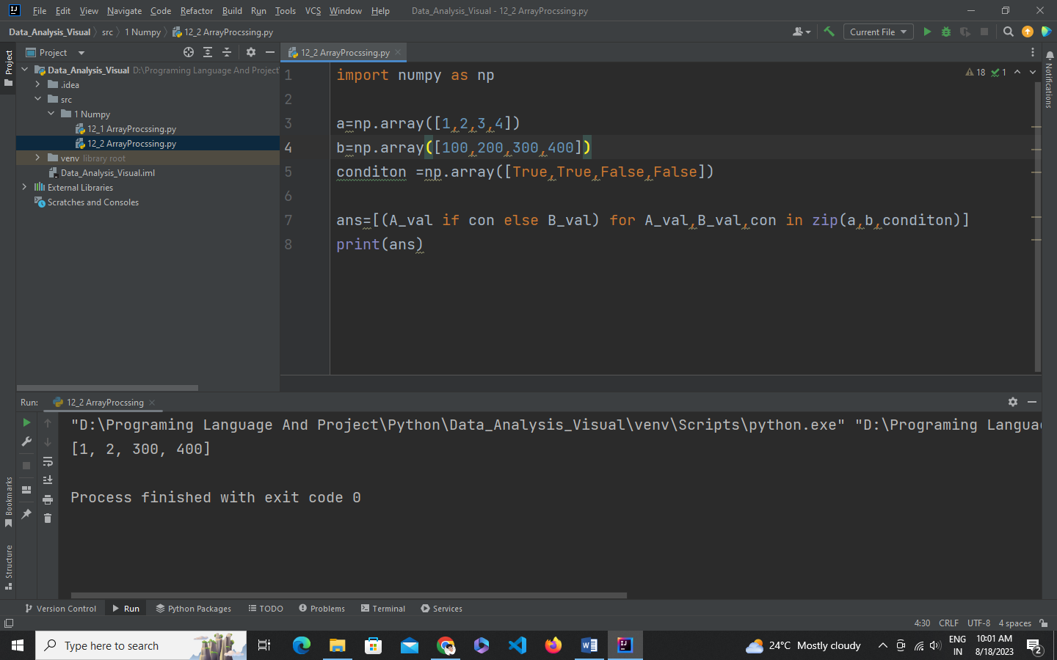

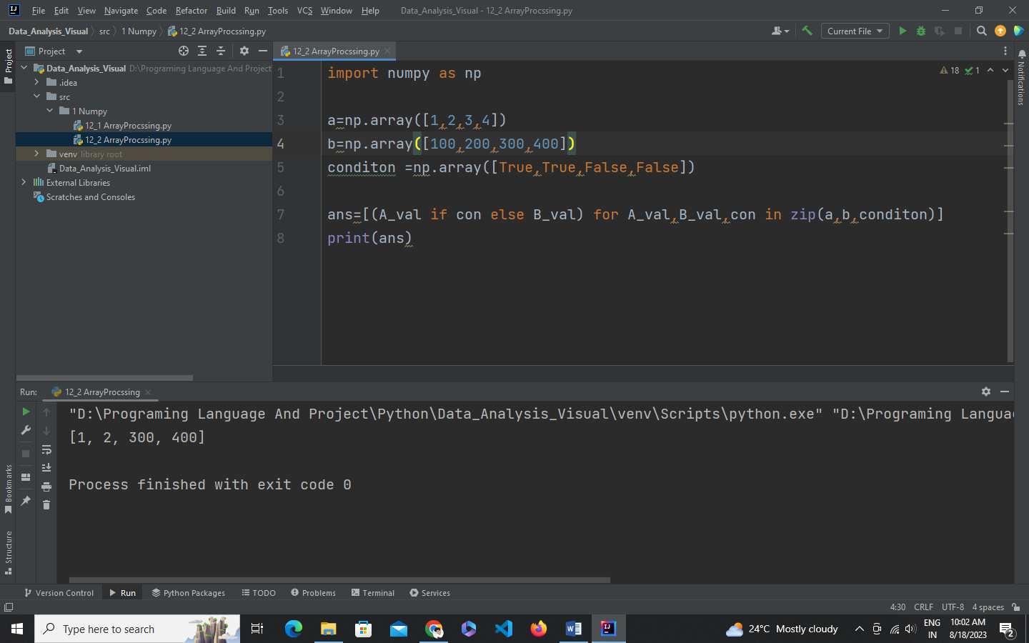

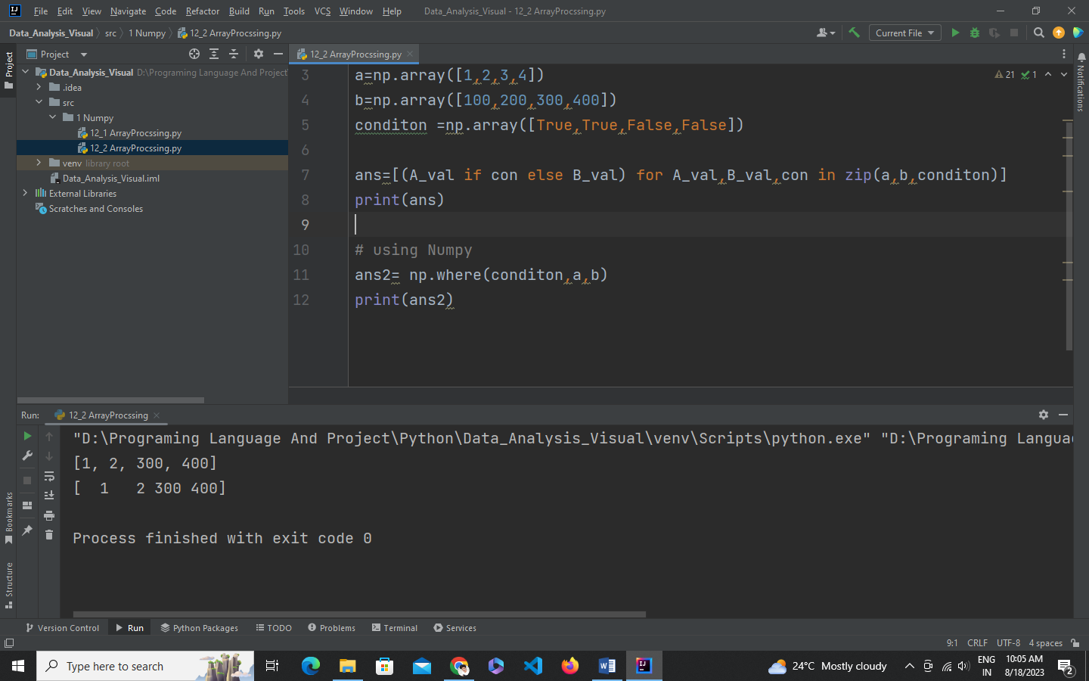

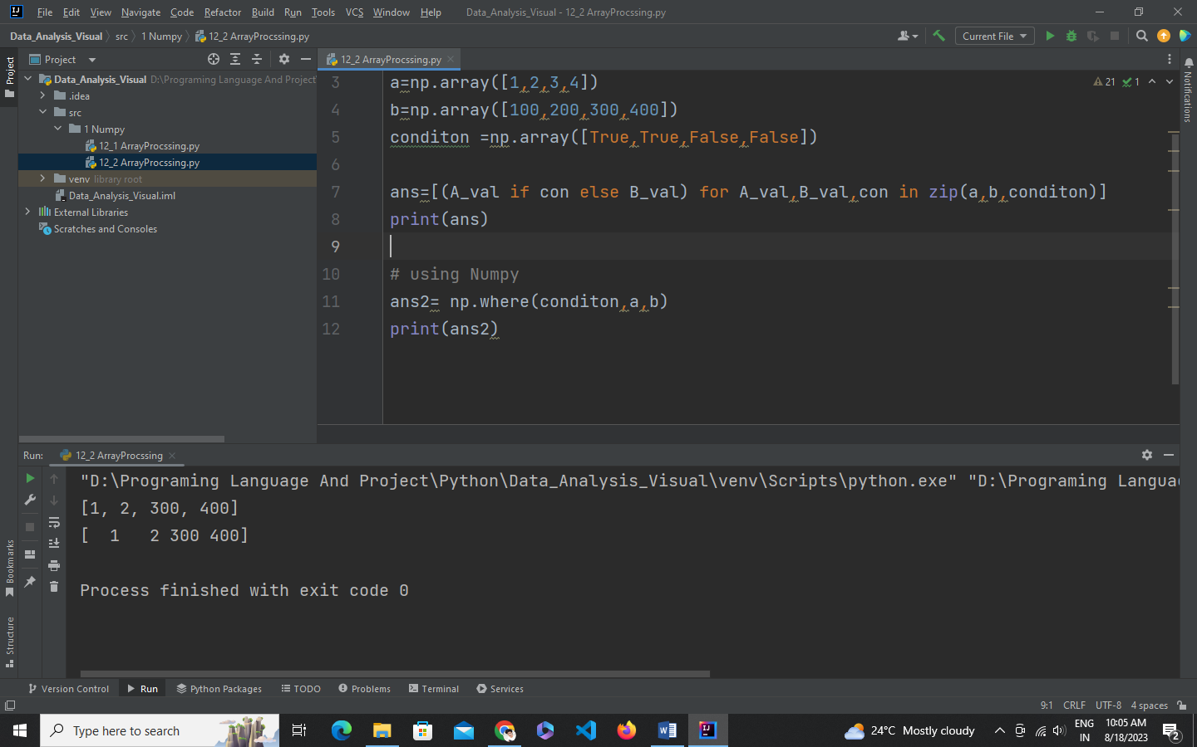

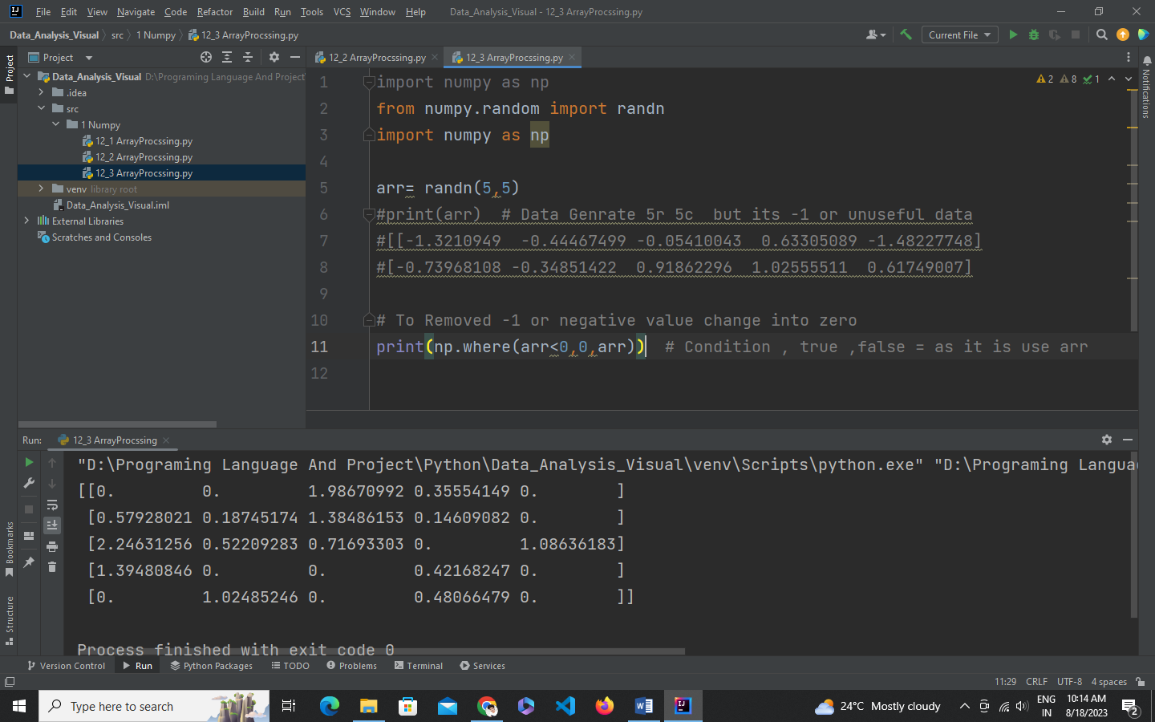

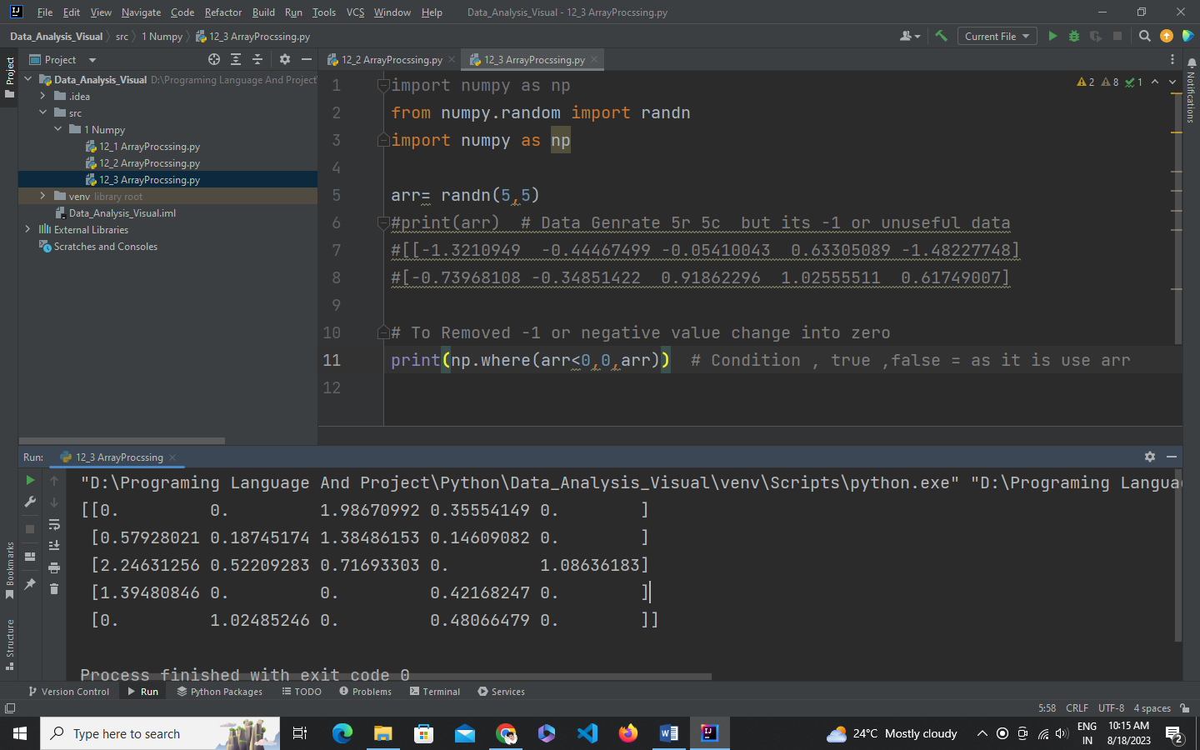

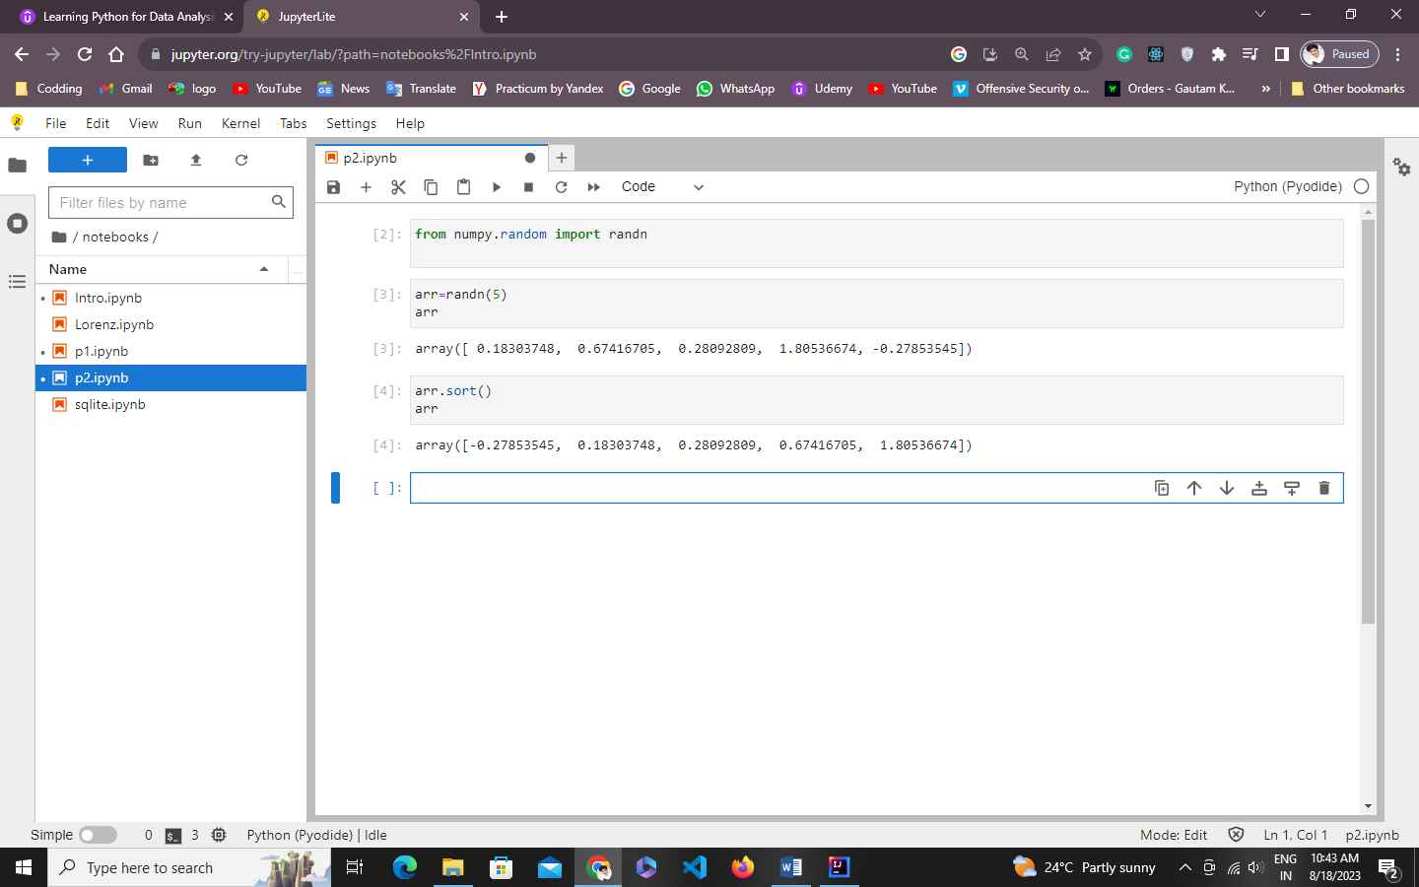

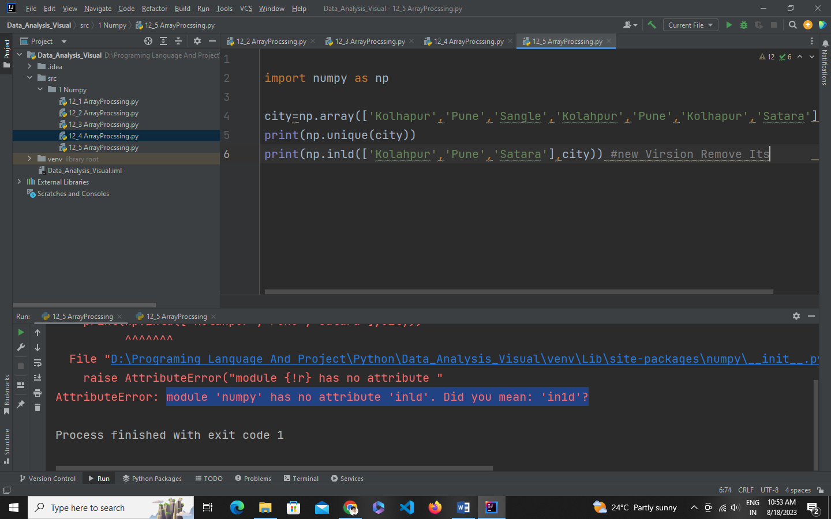

Array Input Output

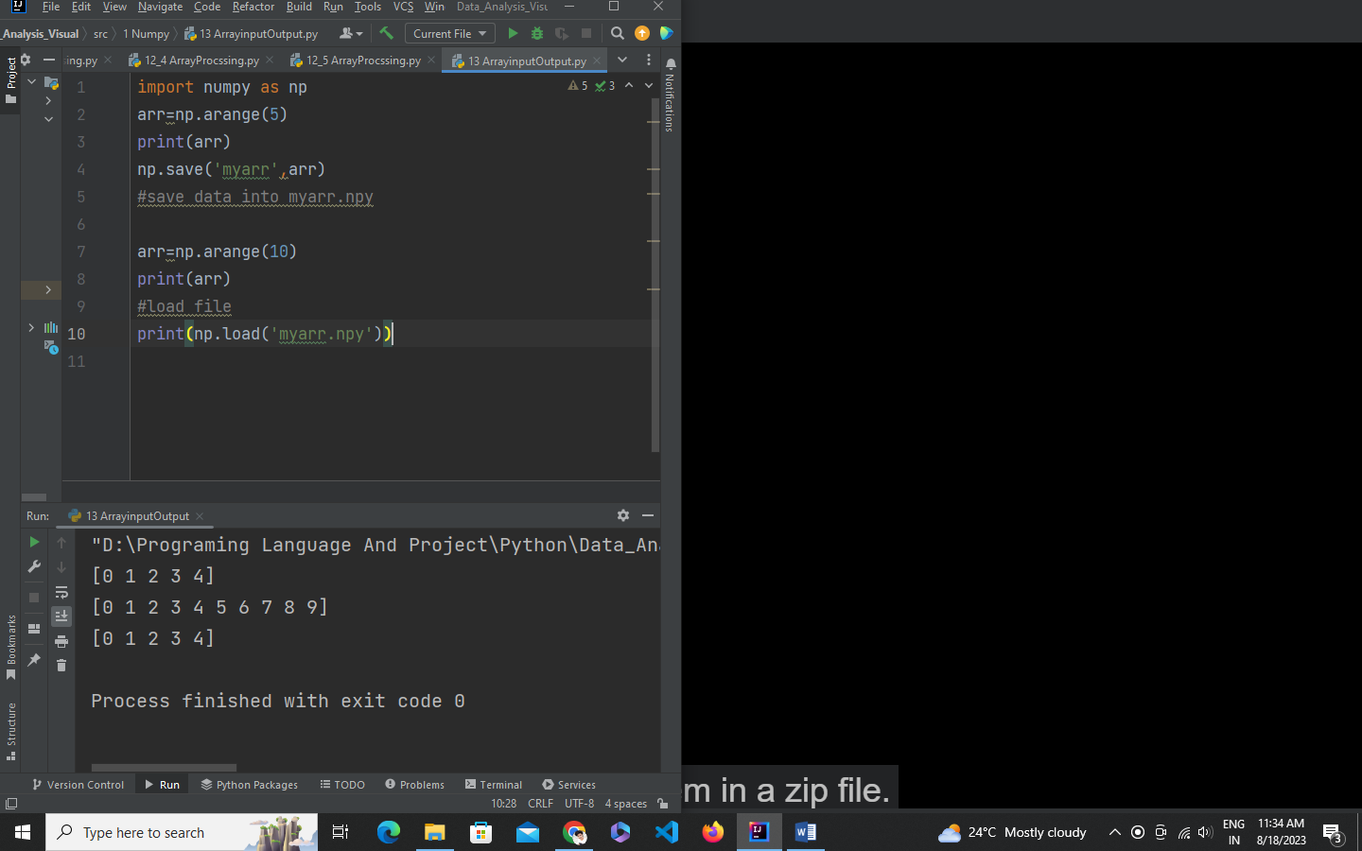

Zip array

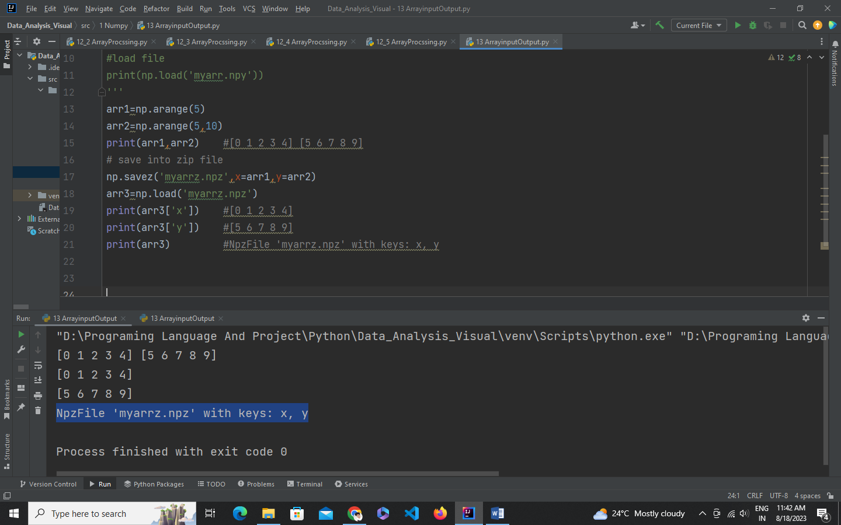

arr=np.array([[1,2,3],[4,5,6]])  
print(arr) # [[1 2 3]  
 # [4 5 6]]  
np.savetxt('myarry.txt',arr,delimiter=',') #delimiter is add , after number into text file  
arr=np.loadtxt('myarry.txt',delimiter=',')  
print(arr)

[[1. 2. 3.]

[4. 5. 6.]]